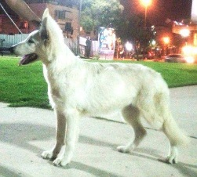Eternal flame Star of David “Carolla” 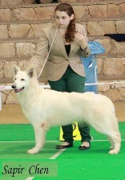

Dam born: 13. January 2013
Linebreeding - 5 generations |  | Inbreeding coefficient
Father - Mother | Who | Wright's | Hardiman's
3 - 5 | WWBBI 2007 - AUTCH X-Dream Amaroq of White Mountain Austria SCHH3, IPO3, OPO3 | 00.79% | 04.49%
5 - 5 | Aliena von White Princess BH, SCHH3, IPO3, FH 1 | 00.20% | 02.05%

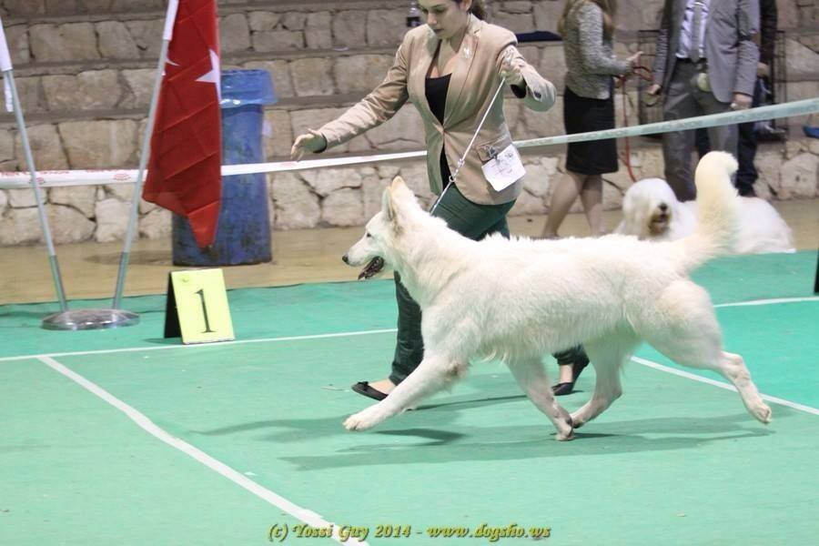

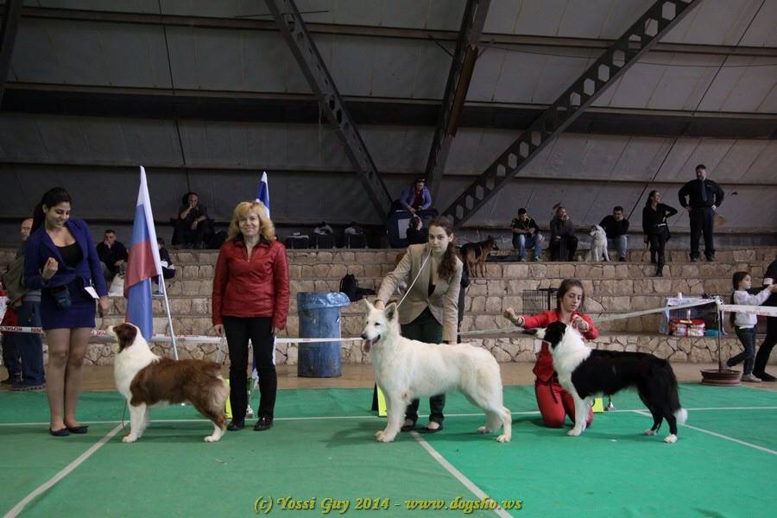
White Falcon's Leo  2010  HD-  Sire | IPO 1 - 3  BOB,BUNDESSIEGER Joyner Boss vom Sutumer Grund IPO 1 - 3  2008  HD-FCI: A 1/2  Sire  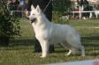 | IPO 3, SCHH 3, VPG 2, BH, AD, MDR1 +/+, DM N/N  BS'07, ES'08, VWW'09 Bossanova von White Angel IPO 3, SCHH 3, VPG 2, BH, AD, MDR1 +/+, DM N/N  2001  VR 19926  HD-FCI: A 1/2  Sire  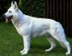
BH/VT, SCHH 1
DTCH VDH VWW'12 U'Raja of Haely's Future BH/VT, SCHH 1
2002
VR 2430942
HD-FCI: B 1/2
Dam
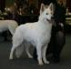

 | AD, BH, IPO 3  White Falcon's Aicha-Shakira AD, BH, IPO 3  HD-FCI: A 1/2  Dam | SCHH3, IPO3, OPO3  WWBBI 2007 - AUTCH X-Dream Amaroq of White Mountain Austria SCHH3, IPO3, OPO3  2001  ÖHZB WS 333/Reg  HD-FCI: A 1/2  Sire  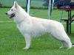
BH, SCHH 1
Bounty vom Klosterberg BH, SCHH 1
1999
HD-FCI: A ½
Dam

CH. SLO White rose D Lola  2010  SLRAK 000298  HD-FCI: A 1/2  Dam  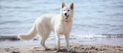 | B-BH|  CH. Ferrari Von White Rose B-BH  2005  SLAKO 000147  HD-FCI: A 1/2  Sire  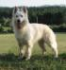 | CH-SLO,BIH Delljoy of Haely's Future  2004  SLRAK 000130  HD-FCI: A 1/2  Sire  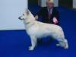
B-BH
CH. Alfa Meziska B-BH
2000
SLAKO 000010
HD-FCI: A 1/2
Dam
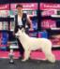

 | CHJ. Vivid Daydream Daily-Kaya  2007  SLAKO 000227  HD-FCI: A 1/2  Dam  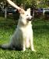 | MDR+/+ , DM N/N , HÄMOPHILIE FREE  V1, V2 Nice of you to Come Bye Cumano MDR+/+ , DM N/N , HÄMOPHILIE FREE  2004  NHSB 2517387  HD-FCI: A 1/2  Sire  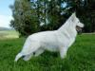

AMARUSHAYA von der Nordhelle
2005
HD-FCI: A 1/2
Dam
